**DATE:-23/09/2022**

**Practical No. – 3**

**Objective:** *Write a program in C to find the difference of two set A and B:(A-B)*

**Theory:**

* **Difference:**​-

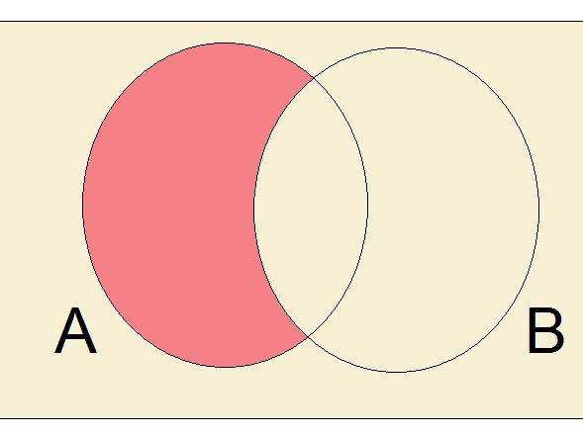If A and B are two sets, then their difference is given by A - B or B - A.   
  
• If A = {2, 3, 4} and B = {4, 5, 6}   
  
A - B means elements of A which are not the elements of B.   
  
i.e., in the above example A - B = {2, 3}   
  
In general, B - A = {x : x ∈ B, and x ∉ A}   
  
• If A and B are disjoint sets, then A – B = A and

B – A = B

**Source Code:**

#include <stdio.h>

int main()

{

    int i, j, m, n, f = 0, k = 0;

    int a[100], b[100], c[100];

    printf(" Name:-PANKAJ KUMAR \n");

    printf("Roll no.:-2100320120122 \n");

    printf("enter the size of seta");

    scanf("%d", &m);

    printf("Enter the element of seta");

    for (i = 0; i < m; i++)

    {

        scanf("%d", &a[i]);

    }

    printf("enter the size of setb");

    scanf("%d", &n);

    printf("Enter the element of setb");

    for (i = 0; i < n; i++)

    {

        scanf("%d", &b[i]);

    }

    for (i = 0; i < m; i++)

    {

        for (j = 0; j < n; j++)

        {

            if (a[i] == b[j])

            {

                f = 1;

                break;

            }

            else

            {

                f = 0;

            }

        }

       if (f == 0)

     {

        c[k] = a[i];

        k++;

     }

    }

    printf("Difference operation on set a&b \n");

    for (i = 0; i < k; i++)

    {

        printf("%d ", c[i]);

    }

    return 0;

}

**Output:**

